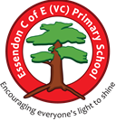
Essendon C of E (VC) Primary School
Encouraging Everyone’s Light to Shine (Matthew 5:16)
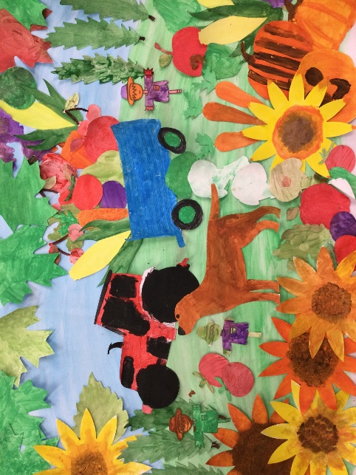
The children in Diamond class made this collage alongside the
‘All Sorts’ Club in the village hall.
Harvest Service
Thursday 16th October 2025 9:30 am
St. Mary’s Church, Essendon

Opening Prayer from Church

Welcome from Mr Brennan

Song: Cauliflowers Fluffy
Cauliflowers fluffy and cabbages green
Strawberries are sweeter than any I've seen
Beetroots purple and onions white
All grow steadily day and night

The apples are ripe and the plums are red
The broad beans are sleeping in their blanketty bed

Blackberries are juicy and rhubarbs sour
Marrows fattening hour by hour
Gooseberries hairy and lettuces fat
Radishes round and runner beans flat

The apples are ripe and the plums are red
The broad beans are sleeping in their blanketty bed

Orangey carrots and turnips cream
Reddening tomatoes that used to be green
Brown potatoes in little heaps
Down in the darkness where the celery sleeps

The apples are ripe and the plums are red
The broad beans are sleeping in their blanketty bed, Yeah!

The Harvest Song: Ruby Class

Song: Thank you for a million brilliant things
Thank you for this day and all it brings.
Thank you for a million brilliant things.
Thank you for the food we have to eat.
Thank you for the friends we’ve yet to meet.
Thank you for tomorrow and for yesterday
And for every day we see.
Thank you for the freedom to be me.
Thank you, thank you.
Thank you for the freedom to be me.
Thank you for the sunshine and the rain.
Thank you for the life that they sustain.
Thank you for our peace and harmony.
Thank you for our strength and unity.
Thank you for tomorrow and for yesterday
And for every day we see.
Thank you for the freedom to be me.
Thank you, thank you.
Thank you for the freedom to be me.
Thank you for our parents and our home.
Thank you for the love that they have shown.
Thank you for our school and for its care.
Thank you for our teachers who work there.
Thank you for tomorrow and for yesterday
And for every day we see.
Thank you for the freedom to be me.
Thank you, thank you.
Thank you for the freedom to be me.
‘In My Trolley’ Song: Emerald Class

Harvest Poems: Sapphire Class

Song: Harvest Rock and Roll
Clap your hands together for harvest time!
Everybody come and stand in line.
Put your best foot forward and dig the earth;
Time to do some weeding for all your worth!
Scatter all the seeds, then take a rest.
Pray that with good weather we’ll be blessed,
And then with your heart and soul
Join in the harvest rock and roll!
Oo yeah, harvest rock and roll!
Oo yeah, harvest rock and roll!
Oo yeah, harvest rock and roll!
Oo yeah, harvest rock and roll!
And now with your heart and soul
Join in the harvest rock and roll!
Harvest Reading: Diamond Class

Reading 1: “The Gift of the Earth”
Today we gather to celebrate the harvest — the time when the earth gives back the fruits of our care and hard work.
The seeds we planted in spring have grown into golden wheat, juicy apples, and bright orange pumpkins.
But harvest is more than food — it’s a reminder to be thankful.
Thankful for the sun that warmed the soil, the rain that watered the roots, and the hands that helped things grow.
Let us remember to share what we have, help those in need, and care for the world that feeds us all. This links with our ‘Going for Gold’ value of Kindness.

Closing: Mr Brennan
Closing Prayer: Church

