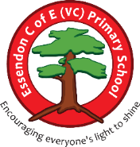
Ruby Autumn 2025 Overview
Class teacher – Mrs Pryke - Teaching Assistants – Miss Hodgson, Miss Holding
In the early years foundation stage (nursery and reception), we deliver our curriculum following children’s interests, planned topics, subject sequences. We have three core areas within the EYFS stator framework: Communication and language, personal, social and emotional development and physical development. These three areas are key for children to develop the skills and understanding needed to support the four foundation areas which are: literacy, mathematics, understanding the word and expressive art and design.

Term | Autumn 1 | Autumn 2
Termly Themes | Beautiful Beings
EYFS  Termly Topics | All About Me | My Favourite Story Book
EYFS  Termly Topics | Feelings and Emotions  Unique Me  Understanding Resilience and Determination | Families  Friendships  Communities and My School
Topic Core Texts | - All Kinds of People  - Faces  - You Can  - That’s Not My Name  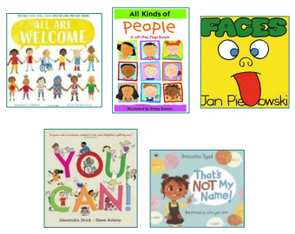  - All Are Welcome | - Beegu  - Hug  - We’re Going On A Bear Hunt  - The Tiger Who Came To Tea  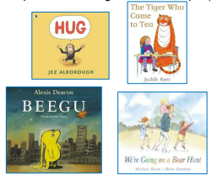
Whole Year Learning | Festivals and Celebrations
Whole Year Learning | - Guy Fawkes | - The Nativity
Whole Year Learning | Seasons
Whole Year Learning | - The Leaf Thief | - The Snowman
Personal, Social and Emotional Development
Knowledge and Skills Progression

To learn to express feelings and consider the feelings of others.
To identify and moderate own feelings socially and emotionally.

To see themselves as a valuable individual.
To think about the perspectives of others.
Communication and Language
Knowledge and Skills Progression
To begin to respond to visual and verbal prompts to learn the skills to help them to listen carefully on the carpet and in a range of situations.
To begin to learn new vocabulary linked to books and themes and use throughout the day.
To begin to describe events connecting one idea with another.
To begin to use talk to help to work out simple problems to organise thinking and use this to begin to explain how things work and why.
To begin to listen to and learn songs and rhyme and how they sound.
To begin to engage in story times and in non-fiction books for a short amount of time and begin to join in with repeated actions and phrases.
To begin to hear some simple social phrases for example ‘Good morning’. Saying ‘please’ and ‘thank you’ following prompts.

Physical Development
Knowledge and Skills Progression
To begin to progress towards a more fluent style of moving, with developing control and grace.
To begin to develop the overall body strength, co-ordination, balance and agility needed to engage successfully with physical education sessions and other physical disciplines including dance, gymnastics, sport and swimming.
To begin to combine different movements with ease and fluency.
To begin to use a range of large and small apparatus indoors and outside, alone and in a group.
To begin to develop overall body-strength, balance, co-ordination and agility.
To begin to develop and refine a range of ball skills including: throwing, catching, kicking, passing, batting, and aiming.
To begin to develop confidence, competence, precision and accuracy when engaging in activities that involve a ball.
To begin to develop the skills needed to manage the school day successfully e.g lining up and queuing / mealtimes / PE

Literacy / Phonics
Reception: In Phase 2, children learn a Grapheme-Phoneme Correspondence (GPC) for most of the 26 alphabet letters. This means they learn the sound (phoneme) that is represented by a letter (grapheme).
Unit 1 s/a/t/i/p
Unit 2 i/n/m/d
Unit 3 g/o/c/k
Unit 4 ck/e/u/r
Unit 5 h/b/f/l
In Phase 3, children begin to learn digraph and trigraph GPCs for sounds not introduced so far. Digraphs and trigraphs are when 2 or 3 letters represent 1 sound.
Unit 1 ff / ll / ss /j
Unit 2 v/w/x / y
Unit 3 z/zz/qu /ch +words with s/s added at the end (hats sits)
Unit 4 /sh/th/ng/nk
Unit 5 words with s /s/ added at the end (hats sits) • words ending s /z/ (his) and with s /z/ added at the end (bags)

Exposure to and learning to read and spell irregular words:
Is, I, the, put, pull, full, as, and, has, his, her, go, no, to , into, she, push, he, of, we, me, be

Mathematics
Reception:
Match Sort and Compare
Talk About Measure and Patterns
It’s Me One, Two, Three
Circle and Triangles
1,2,3,4,5
Shapes with 4 sides.

Nursery:
More than, fewer than, same
Explore and build with shapes and objects.
Explore repeats.
Hear and say number names.
Beginning to order number names

Understand the World
Using our senses to investigate the change in seasons.

Explore the celebrations that occur this term, including; Fireworks night, Remembrance Day and Christmas.
Expressive Art and Design
Colour mixing.

Using different media inside and outside.

Exploring how to create sounds with different instruments.

Exploring their environments through forest school and Child Initiated Play.
Nursery rhymes
Nursery rhymes and singing will become a routine part of our day in Pantherswood. Through song and rhyme repetition is used to embed new vocabulary, concept and number awareness.
Our singing and rhyme time will be accompanied with props and resources to stretch children’s understanding while being a time of day we can all come together in shared experience where all children can access and enjoy.

